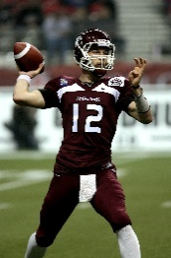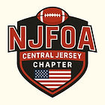

1st Annual NJFOA Central Jersey Golf Outing
MONDAY, JULY 20TH 2026
PEDDIE GOLF CLUB
671 Old York Rd. East Windsor NJ 08520

Sponsor Registration Form

Sponsor Name:
Contact Name:
Phone Number: Email:
Company Website (if applicable):
Payment Type (circle one): Check / Venmo @Bruce-Cronauer
Make Checks payable to: NJFOA – Central Chapter
Mail completed Sponsorship Form with check to:
17 Hendrickson Manalapan NJ 07726
Sponsorships Opportunities
(mark your selection below)

Beverage Sponsor ($1,000): Sponsor the beverage cart on the Golf Course.
Breakfast Sponsor ($500): Sponsor the “Before Golf Continental Breakfast”.
Halfway House Sponsor ($500): Sponsor the Halfway House where golfers will enjoy food and drinks on the course.
Lunch Sponsor ($1000): Sponsor the “Tailgater Lunch Buffet”.
Skills Contest Sponsor ($350): Sponsor any one of the following contests: Putting Contest, Hole-in-One, Closest-to-the-Pin, Longest Drive, Straightest Drive, Double Your Money, or Beat the President.
Hole Sponsor ($200): Sponsorship includes a sign advertising your business.
Cart Sponsor ($150): Sponsor a Golf Cart advertising your company name.

Have questions or need additional information please contact:
Bruce Cronauer: (732) 616-9524 / bwctbs29@aol.com

NJFOA Central Jersey Chapter is a registered 501C3 organization

